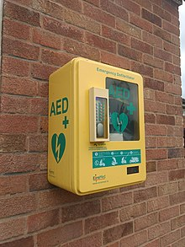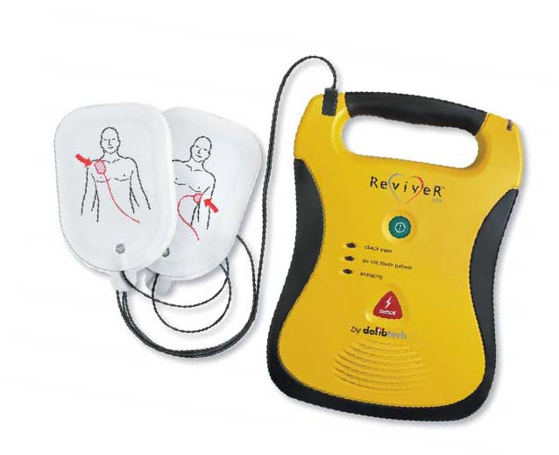

Training for the recently fitted defibrillator in the old telephone kiosk has been re-arranged for the evening Friday 2nd October 2020 at 19:30 hrs and will be held at the Great Rissington Club house.
If you are interested in learning how to operate the defibrillator and put your name down as a point of contact please feel free to attend.
In the interest of Covid – 19 protection, please note the club house will be open to the public as per normal therefore, you may wish to wear a mask during the training.
The seating will be organized with as much space as possible.

