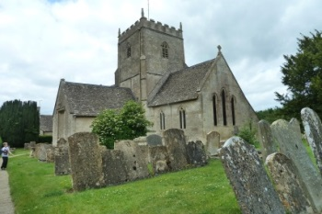 | St John the Baptist  Great Rissington

St. John's offers a variety of service formats and times to suit varying preferences and tastes! From traditional to contemporary, early morning to evening, we welcome you to come along and see what we have to offer. Visitors are very welcome.
First Sunday: 09.30
Traditional Eucharist – ‘Said’ service

Second Sunday: 11.00
Informal Coffee Church
exploring the basics of Christianity -
a friendly introduction to a less formal Church.

Third Sunday: 11.00
Joint Rissingtons Family Communion
contemporary language – in rotation with
Little and Wyck Rissingtons

Fourth Sunday:
18.00 Traditional Evensong

And special events celebrating the life of the Church

